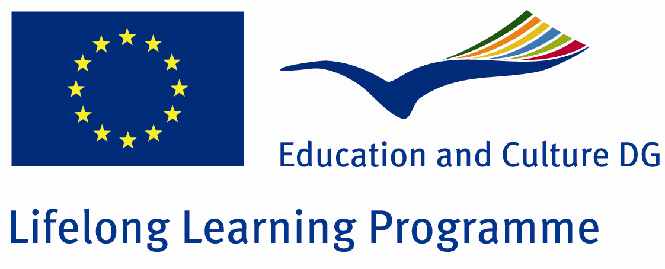
LEONARDO DA VINCI TRANSFER OF INNOVATION PROJECT
Under the Lifelong Learning Programme n° LLP-LdV-TOI-2011-LT-0094
Marketing Text
Frequently, young mothers think, that children having Down’s syndrome are often born in asocial families, due to bad addictions of expectant mothers. However, the risk is the same for all races, social groups, and people with different educational and religious backgrounds. The news about the ill baby is equal to tornado, which destroys for everything. Parents believe that the baby’s birth will be one of the most exciting moments of their lives; sadly, it appears as one of the most difficult events they have ever suffered. They feel the psychological load, anger, oppression and compunction. If they refuse the baby, they are judged by society, and reconciliation is usually too heavy. It can deeply shock the family or even destroy it. Therefore, it is important for professionals to identify Down’s syndrome as early as possible. This project 11–13 week scan is intended exactly for the reason. It enables parents to take the adequate decision easier and earlier under such pathologies.
Summary
First-trimester mandatory ultrasound is not included in the Lithuanian and Latvian Minister of Health established order of antenatal care. In developed countries like the UK and in the first trimester of pregnancy from 11 weeks to 13+6 weeks of gestation chromosomal abnormality screening is performed to all pregnant women. Lithuania and Latvia, for the first trimester screening there is no even a single agreed methodology. The study is carried out exclusively for women only at risk prenatal centre, but specialist expertise in this area are scarce and heterogeneous findings.
Methodologies used are incomplete, outdated, and different. Lithuanian literature is not available. Every obstetrician further relies on his experience and knowledge, but do not have any possibility to rely on a standardized methodology adopted.
Aims:
1. To create first-trimester of pregnancy ultrasound “11-13 WEEK SCAN” methodology in Lithuanian and Latvian
2. To create the remote educational system for “11-13 WEEK SCAN” in Lithuania and Latvia
3. To transfer the ready course in Lithuanian and Latvian to Fetal Medicine Foundation to United Kingdom to the other courses in 20 languages
Partners:
1. Fetal Medicine Foundation is the first trimester chromosomal abnormality screening pioneers and current leaders in this field.
2. Lithuanian University of Health Sciences is a major university in Lithuania in the medical field. With 26 thousand medical communities, he has the greatest influence on the LT health system.
3. JSC ‘Arbor Medical Corporation LT’ supplies various ultrasound equipment to hospitals, they are familiar with the technical side. Employees conduct trainings on how to use it, provides information about each product and specification.
4. Latvian Obstetricians and Gynecologist Association (LGOA) brings together more than 400 obstetricians and gynecologists in LV.
Outcomes:
1. Single rate method in 11-13 week scan study in LT and LV.
2. After the confirmation of distance learning course and reaching to make it compulsory Lithuanian and Latvian obstetricians-gynecologists and medicine students’ competence will increase, mistakes and un-correct conclusions will be avoided, the test quality will improve.
3. After the project will be aimed that 11-13 WEEK SCAN test based on the courses, be carried out on all pregnant women, in LT and LV.
4. The 11-13 WEEKS SCAN courses in Lithuanian and Latvian will be involved to Fetal Medicine Foundation courses, in UK. (Currently they have 20 languages).

Description
This is an essential project to bring the fetal medicine in Baltic States (Latvia and Lithuania) one step in forward. As the consequence of this project the Latvian and Lithuanian gynaecologists are going to be able to read early ultrasound scan outcomes and this is what permits to achieve more qualified service and ensure births of the healthier babies. We are ready to achieve more qualified and certificated gynaecologist stuff, better quality of the gynaecologist services and to create the conditions through enabled practitioners for the further early scan methodology development within this project. This is going to be achieved through creating initial 11-13 week scan methodology in Latvia and Lithuania, as well as through creating remote educational system. This project, which through the innovation of reading early scan outcomes originated from UK will be transferred to the Baltic states, are about to create the consequent collaboration between the mentioned countries also after the project, bringing the further development in the field. “The 11-13 week scan“ project is one of the innovation transfer projects under the Program Life Long learning and sub-program Leonardo Da Vinci. The both titles (LLL and Transfer of innovation) can be justified through the content of the project. First of all, the project will enable the Latvian and Lithuanian gynecologist to develop their professional skills in favor of the extra institutional education and, moreover, permits the widening of the fetal medicine possibilities in mentioned countries through the transfer of the UK originated innovation to the Baltic States. Through the project the collaboration between partners will bring the unified and single methodology of 11-13 week scan in Latvia and Lithuania, following the creation of the remote educational system and the outcomes of the methodology development in Latvian and Lithuanian will be transferred to UK partner’s educating system.
Themes
Quality
Intercultural learning
Lifelong learning
Recognition, transparency, certification
Open and distance learning
Continuous training
Sectors
Human Health and Social Work Activities
Product Type
stransparency and certification
CD-ROM
material for open learning
evaluation methods
Product information
Within the project the intermediate and final products will be created. As the intermediate outcome of the project the creation of remote educational system is to be regarded (it is also the mean in order to achieve the project goals). In the long term this education system is expected to become the basis for the universities' programs. The publishing of basic theoretical course in Latvian and Lithuanian languages, the methodological material – the manual of the basics on how to read the 11-13 week scan – and the certified methodology for the gynecologist, as well as the compulsory 11-13 week scan in Latvia and Lithuania ruled by state legislation are to be regarded as the final result of the project. Therefore, the transfer of ready course in Lithuanian and Latvian into the virtual platform of Fetal Medicine Foundation - the partner from United Kingdom - and that is how the course will be added in two additional languages (currently there are courses in 20 languages).

